**Progress**

**On a scale of 1 to 10, how would you rate the progress you’ve made this week?**

**Answer:**

On a scale of 1 to 10, I will rate the progress in have made 8.

**Provide an explanation of your progress assessment this week**

**Answer:**

This week, I was able to start my front-end design. I was able to design the front-end for my homepage.

**What parts of your project are completed as planned?**

**Answer:**

I was able to complete my Home Page front end as planned.

**What aspects of your project are incomplete?**

**Answer:**

Non, based on my proposed project timeline

**Challenges**

**Explain the most difficult technical challenge you encountered in this second week. This answer must be more than 200 words**

**Answer:**

One of the most challenging technical hurdles I encountered in website homepage design revolved around achieving optimal performance while incorporating dynamic and interactive elements.

Initially, my vision was to have a visually striking homepage featuring interactive elements such as animated graphics, carousel sliders, and dynamic content sections. However, integrating these features without compromising page load times and overall performance posed a significant challenge.

To address this challenge, I employed several strategies:

1. **Optimized Asset Loading**: I carefully optimized image sizes and formats to reduce file sizes without sacrificing quality. Additionally, I utilized lazy loading techniques to defer the loading of non-essential assets until they were needed, thereby improving initial load times.
2. **Code Minification and Compression**: I minified and compressed CSS, JavaScript, and HTML files to reduce their size, thereby decreasing load times and improving overall page speed.
3. **Caching Mechanisms**: Implementing browser and server-side caching mechanisms helped reduce the number of requests made to the server and enabled faster retrieval of previously loaded resources.
4. **Asynchronous Loading**: For dynamic content and third-party integrations, I leveraged asynchronous loading techniques to prevent blocking the rendering of critical page elements, thus enhancing user experience.
5. **Performance Monitoring and Optimization**: I continuously monitored website performance using tools like Google PageSpeed Insights and GTmetrix, identifying and addressing performance bottlenecks as they arose.

**Describe the most difficult non-technical challenge you encountered in this second week. This answer must be more than 200 words.**

**Answer:**

One specific challenge I faced was balancing the ambitious vision for the homepage design with the constraints of time and resources. For my ALX project, there was a desire to showcase advanced design techniques, innovative features, and comprehensive content. However, this ambitious scope had to be tempered by the limited timeframe available for completion.

To address this challenge, I adopted a systematic approach to project management, breaking down the design process into manageable tasks and setting realistic milestones. I prioritized essential features and functionalities, focusing on those that were most critical to achieving the project objectives while maintaining a feasible timeline.

Additionally, I regularly monitored progress and adjusted the project scope as needed to stay on track and avoid scope creep. This involved making difficult decisions about which features to prioritize, which to postpone for future iterations, and which to discard altogether if they were deemed non-essential to the project's success.

Furthermore, I practiced effective time management techniques, such as setting aside dedicated blocks of time for design work, minimizing distractions, and avoiding procrastination. By staying disciplined and focused, I was able to make steady progress towards completing the homepage design within the allocated timeframe.

Overall, managing time and project scope effectively was the most challenging non-technical aspect of my final year project. However, by adopting a structured approach to project management, prioritizing tasks strategically, and practicing disciplined time management, I was able to overcome this challenge and deliver a successful homepage design that met the project requirements

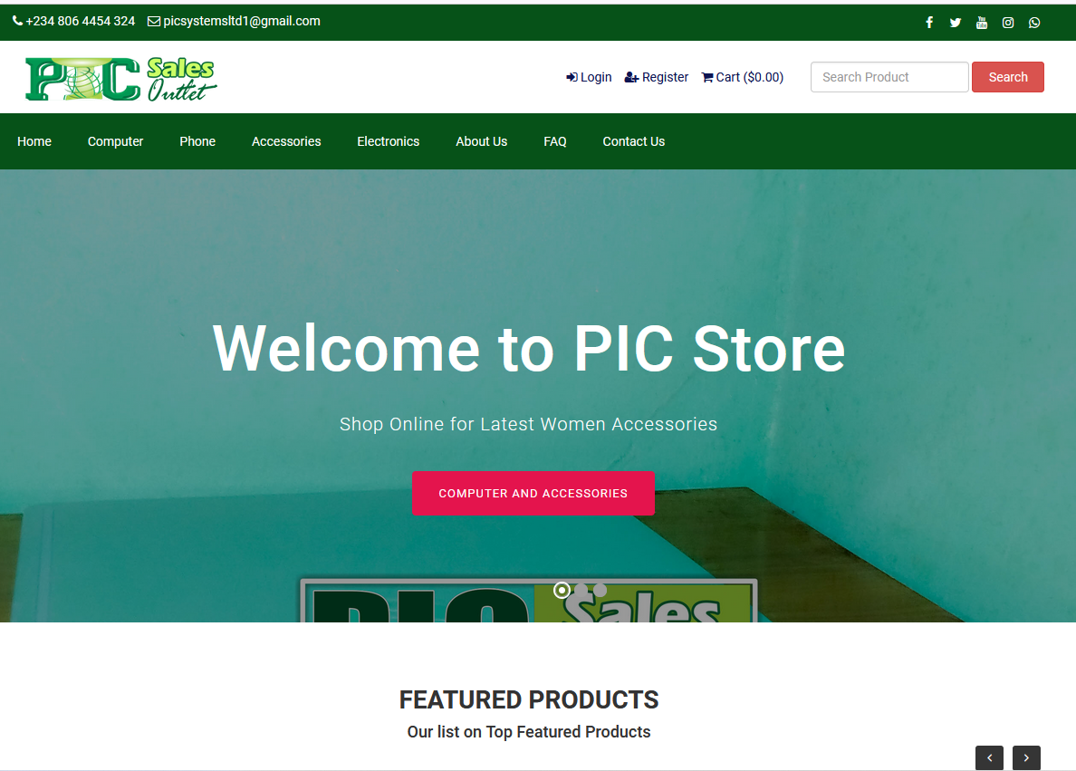**Screenshots**